Complaints Policy and procedure for Apprentices and their Employers
Excellence-Solutions Limited

Author | Elvy Kollasseril
Role | Head of Academy
Version | v1.6
Next Revision Date | 01/10/2026

Introduction

This policy sets out the process for apprentices and their employers to make a complaint about the service provided by Excellence-Solutions Limited.

We are committed to delivering a high-quality service and take complaints from students, apprentices and employers very seriously. It is our aim to settle complaints promptly, fairly and courteously in the best interest of all parties, and to address areas where improvement is needed. We are keen to ensure that the interests and well-being of all those associated with a complaint are properly safeguarded.

Through our complaints process we ensure that:
    - complaints are treated fairly, consistently, transparently, and in a timely manner;
    - matters of concern can be raised without risk of disadvantage and any matter raised that may be considered in line with the principles of whistleblowing will receive the same protections available to Whistle-blowers;
    - where complaints reveal a failure on our part, we take appropriate action to rectify this for the complainant and to identify any others who may have been adversely affected by the same issue;
    - we review aspects of our service in the light of any complaints; and
    - We maintain duties of confidentiality to third parties, or other legal duties, in responding to complaints.

Complaints are logged centrally so that oversight of any emerging trends in complaints or concerns can be assessed by our Complaints and Appeals Review Group (CARG).

Definition
An ‘informal complaint’ is defined as an issue which an apprentice or employer wishes to raise with a member of our staff, without using the formal complaints process. Informal complaints are usually quick to resolve and unlikely to require an in-depth investigation.

A ‘formal complaint’ in this policy is defined as ‘The expression of a specific concern about matters that affect the quality of an apprentice’s learning opportunities, our action or lack of action or the standard of service provided by, or on our behalf’.

Where the complaint is around a request for a review of a decision taken by an individual or academic body responsible for making decisions about apprentices’ progression, assessment or awards, this matter will be dealt

with via the Academic Appeals process. The apprenticeship team will be able to provide you with information on the process to follow.

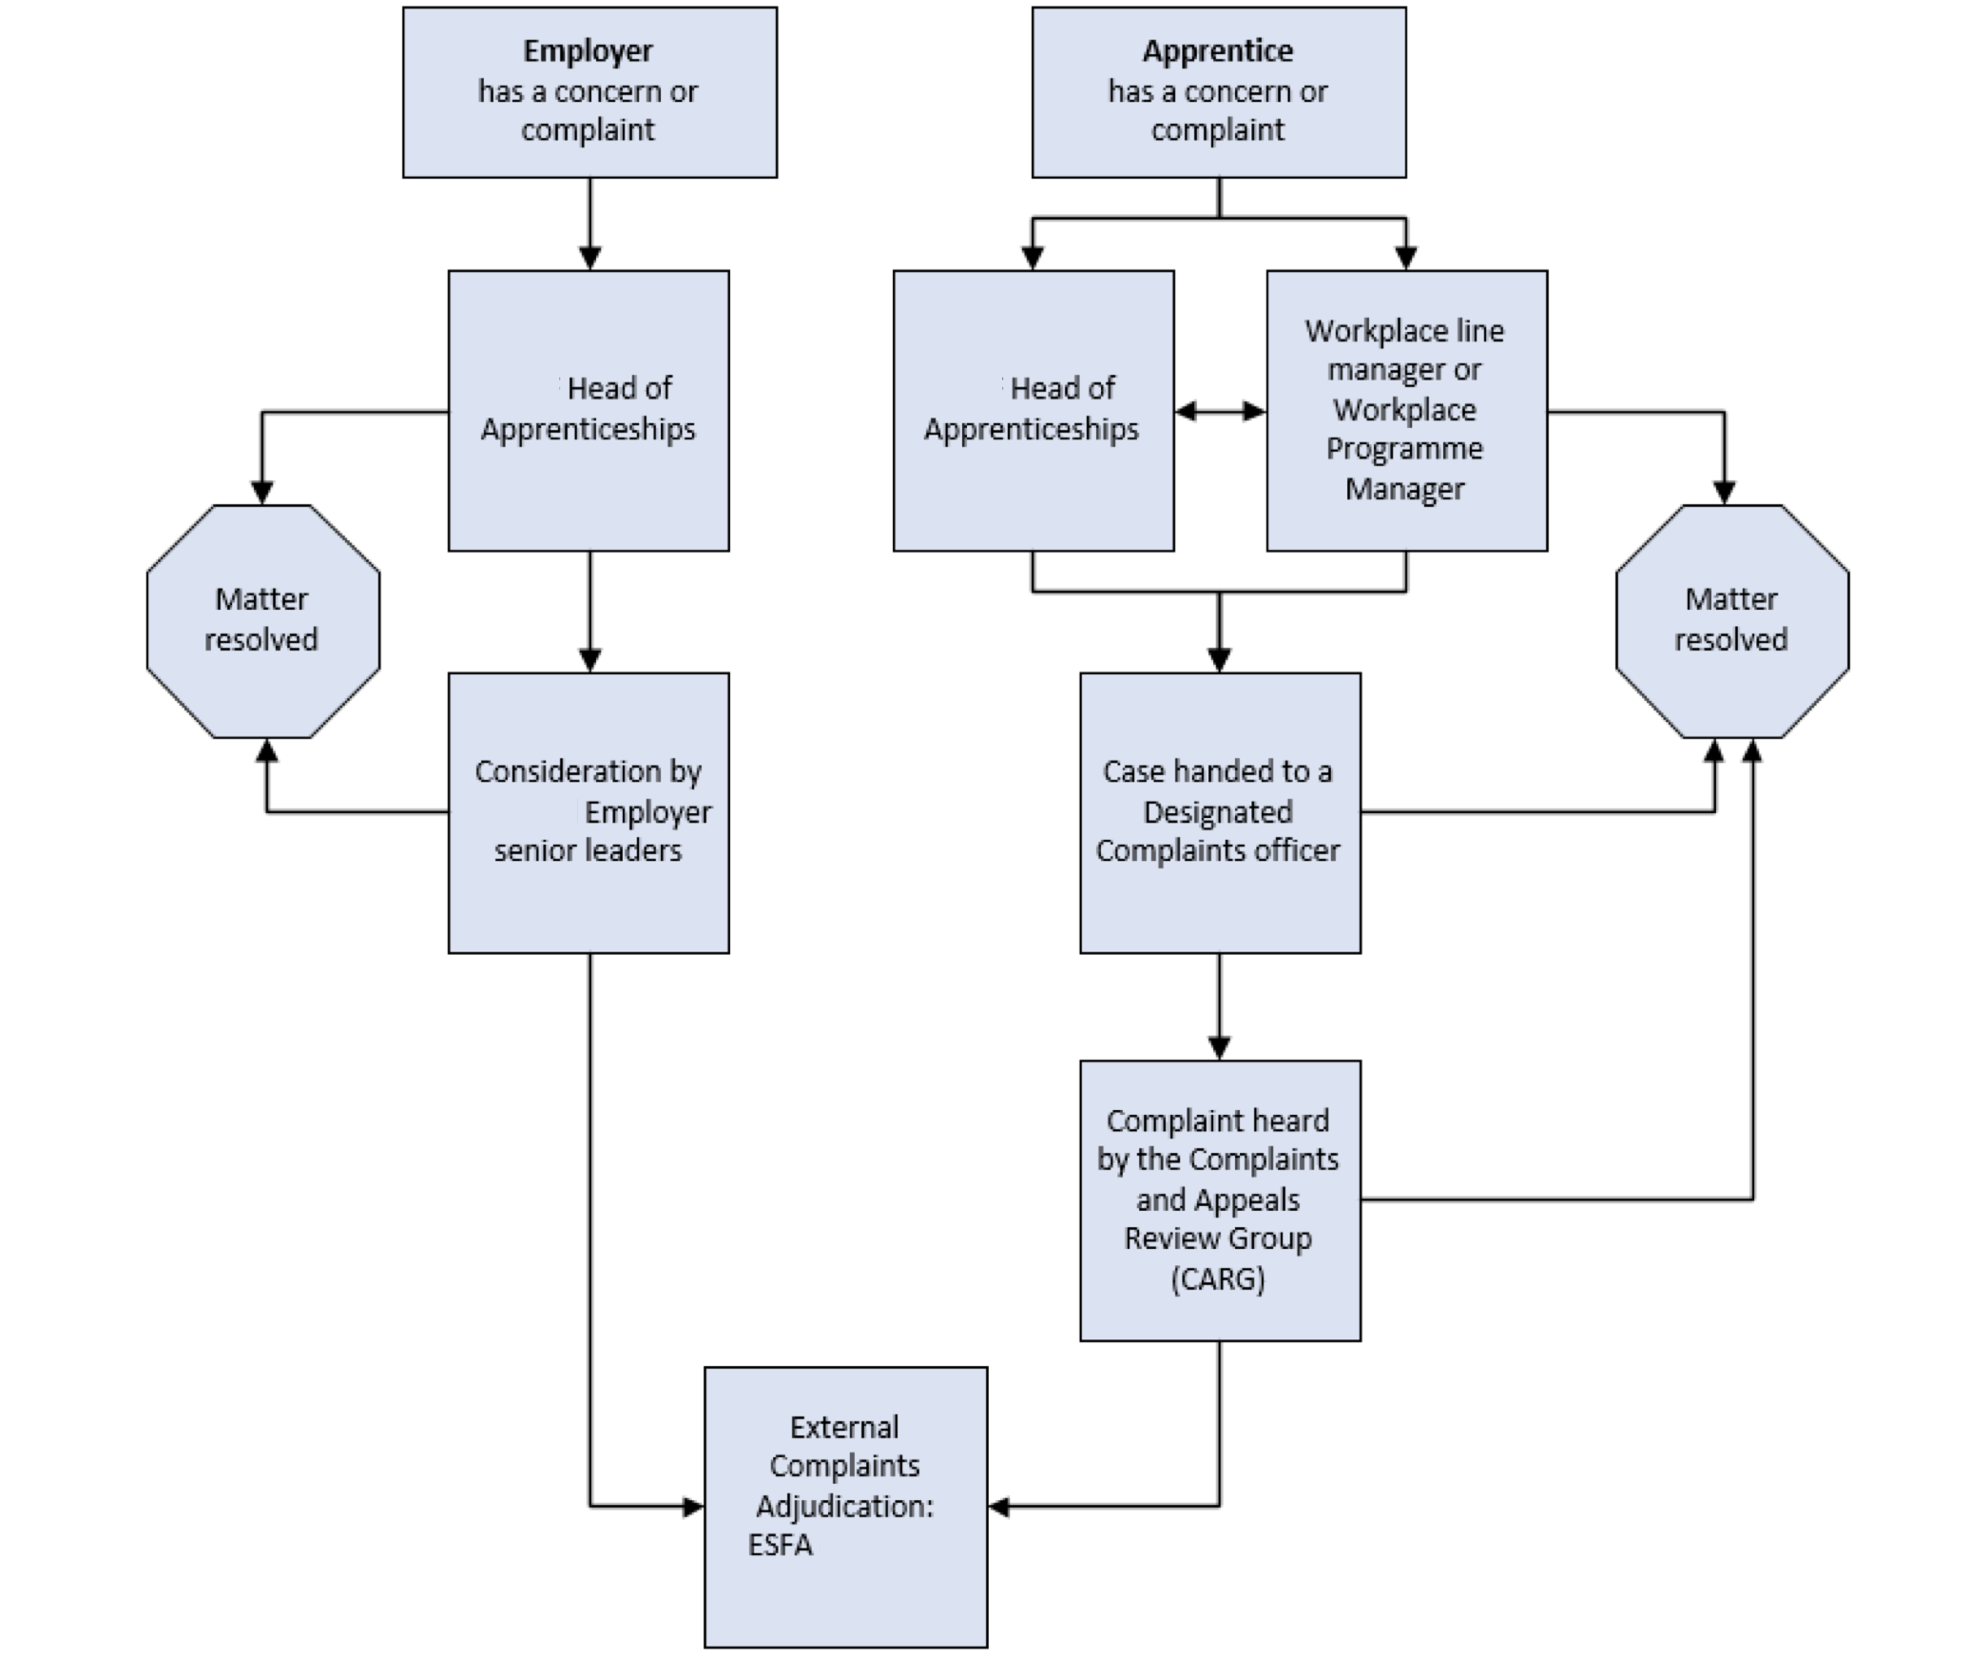

Stage 1 – Informal Complaint
A complaint should be made as soon as possible, ideally within ten working days from the date of the incident occurring. This provides the best opportunity for those involved to be able to resolve the complaint quickly. We reserve the right to dismiss a complaint made more than three months after the incident occurred or that should, within reason, have been highlighted at an earlier point.

A complaint should be raised with the Head of Apprenticeships at the Academy or, for apprentices, with your workplace line manager or workplace Programme Manager who will, in turn, liaise with the Academy if appropriate to help resolve your complaint. The aim is to resolve the problem directly and informally at the earliest opportunity.

Once a complaint is raised with the Academy you should receive an acknowledgement of your complaint within five working days. We will deal with all complaints as promptly as possible and within clearly defined timescales. Where it is not possible to meet these timescales, you will be informed of the progress of your complaint.

Although Stage 1 is informal, the member of staff involved should provide a written outcome to you and copy the Head of Apprenticeships in.

If, as employer, you remain dissatisfied with the outcome of your informal complaint, the Academy will arrange for a representative from your organisation, the Head of Apprenticeships and a senior member of Excellence-Solutions Limited staff, who is independent of the original complaint, to review the complaint together. If following these discussions, you remain dissatisfied with the outcome of your complaint, you may approach the Complaints Adjudicator as detailed in Stage 4.

If, as an apprentice, you remain dissatisfied with the outcome of your informal complaint, you may follow the below complaints process

Stage 2 – Formal Complaint

If together, we are unable to resolve your complaint informally you should escalate your complaint by writing to the complaints@cpba.co.uk and copy in the Head of Apprenticeships. Your email should be titled as a ‘Complaint’.

The complaints team will provide you with a Complaints Form to complete and this should set out the details of the complaint in full, including any evidence you have supporting your concern, what action has been taken to date regarding attempting an informal resolution of your complaint and the resolution you are seeking. If you are unable to submit a complaint in writing due to a reasonable adjustment, please contact the Apprenticeship Team and they will be able to help you submit your complaint.

You will receive confirmation of your formal complaint within five working days and a designated Complaints Officer will contact you to discuss what action has already been taken to try to resolve your complaint and if there is anything further, they may be able to facilitate in order to resolve your complaint at this stage. If there is not and you continue to wish to escalate your complaint through the formal complaints process, the designated Complaints officer will assist in compiling your case to go to the Complaints and Appeals Review Group (CARG).

Stage 3 – Escalation

The complaint will be raised at the next available meeting of CARG. CARG meetings are usually held every 20 days, however, if this timeframe cannot be met, the designated complaints officer will keep you informed of the timescales and when your case will be heard.

You may request to attend the CARG meeting and present the details of your case directly to CARG. If you do not attend, your written case will be reviewed by CARG in your absence.

The standard of proof required at any consideration by CARG is the balance of probabilities.
You will not receive an outcome at the CARG meeting but a formal complaint outcome letter will be sent to you within 10 working days of your complaint being heard by CARG.

Depending on the nature of your complaint CARG may not be able to propose a solution to your complaint even if CARG has accepted it, in this situation CARG contacts the department best placed to address your complaint and request that they provide a suitable resolution. You will receive written confirmation from CARG about their decision and any action(s) to be taken including timescales, within ten working days of the case being heard.

If you remain dissatisfied with the outcome of your complaint following our internal Complaints and Appeal process, you may request that you are supplied with a Completion of Procedures letter, which you can use to support escalation of your complaint to the ESFA Complaints Team.

Stage 4 – Complaints Adjudicator

As the regulator for Apprenticeships, ESFA can be contacted via the Apprenticeship Service Support by emailing complaints.ESFA@education.gov.uk
Or writing to Complaints team
Education and Skills Funding Agency
Cheylesmore House
Quinton Road
Coventry
CV1 2WT

This policy is reviewed annually.

